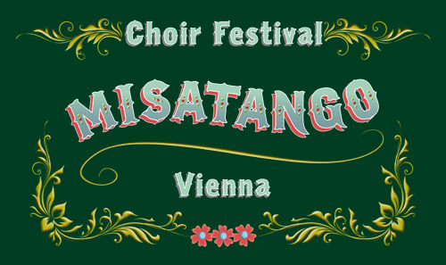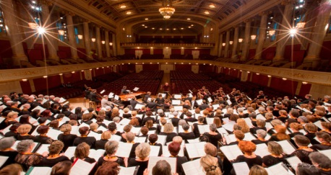

Saul Zaks er kunstnerisk leder for to musikfestivaler som finder sted i Musikverein og i Konzerthaus i Wien. Saul bor i Århus og har været dirigent for Syddansk Universitets Symfoniorkester og Kammerkor i 16 år. Orkesteret – et dansk ungdomsorkester - er blevet nomineret til en Grammy Award i 2016. Saul Zaks har arbejdet med unge musikere og korsangere hele sit liv. Nu bringer han to fantastiske muligheder for danske korsangere og kor.

Arrangør: Concerts Austria

Link til mere information og tilmelding [www.sclfestival.org](http://www.sclfestival.org) ; [www.misatango.com](http://www.misatango.com)

***Misatango Choir Festival Vienna &***

***World Premiere of SALVE REGINA at the Vienna Konzerthaus***

***November 16 – 20, 2022***

***VIENNA***

*Under the baton of Danish Argentinean Maestro Saul Zaks, with composer Martín Palmeri at the piano and international soloists, participating choirs will jointly perform the “Misa a Buenos Aires”, a contemporary roman mass in an authentic Argentinean tango style, and the world premiere of Palmeri’s newest composition “Salve Regina” at the great hall of the Wiener Konzerthaus.*

*After rehearsing the pieces leading up to the festival, the choirs will have several rehearsals and workshops with Maestro Zaks and Martín Palmeri to get insides, polish the interpretation to an authentic Argentinian style and grow together as a joint choir.*

*This project is meant to be a joyful communal experience of everyone involved with the common goal of a wonderful performance as the concluding highlight of the festival.*

*In case of questions, please don’t hesitate to contact us at* [*info@misatango.com*](mailto:info@misatango.com) *or find more information on* [*www.misatango.com*](http://www.misatango.com)

*For yderligere oplysninger på dansk, kontakt venligst Saul Zaks på 26212520.*